LOGO

Month Date, Year

Jane Smith

1000 S. Carolina St.

City, State Zip Code

## Notice of Service Line Made of Unknown Material

**Dear Customer,**

In accordance with the United States Environmental Protection Agency’s (EPA) revised Lead and Copper Rule (LCRR), XXXXXXXXXXXXXXXXX recently added to our efforts to reduce possible lead exposure in drinking water. Over the last XX months, XXXXXXXXXXXXXXXXX conducted an initial inventory of our service lines that connect our water mains to your water meter to determine if any of the lines are made of lead.

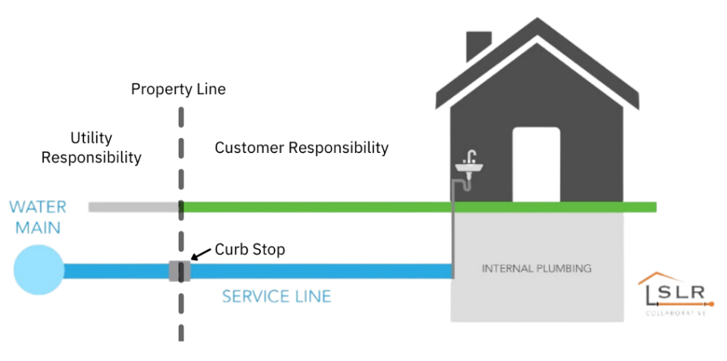

**During our work, XXXXXXXXXXXXXXXXX was not able to determine the material used for the service line delivering water to your property.**  Because your line is “unknown,” there is the potential that some or all the service line could be made of lead or galvanized pipe that was previously connected to lead. People living in homes with a lead or galvanized pipe previously connected to a lead service line have an increased risk of exposure to lead from their drinking water.

It is important to note that finding a line of unknown material does not mean you have been exposed to lead. XXXXXXXXXXXXXXXXX treatment process greatly reduces the possibility lead from service lines could end up in your water.

However, the existence of an unknown line may increase your risk of exposure. This letter serves to notify you of this risk, inform you of steps being taken by XXXXXXXXXXXXXXXXX, and provide information to help you reduce your risk of lead exposure. If you feel our finding is inaccurate, or if you have any questions regarding this letter, please contact us at XXX-XXX-XXX or via email at XXXXXXXXXXXXXXXXXXXX.

**Health effects of lead**

Exposure to lead in drinking water can cause serious health effects in all age groups. Infants and children can have decreases in IQ and attention span. Lead exposure can lead to new learning and behavior problems or worsen existing learning and behavior problems. The children of women who are exposed to lead before or during pregnancy can have increased risk of these adverse health effects. Adults can have increased risks of heart disease, high blood pressure, kidney, or nervous system problems.

**What XXXXXXXXXXXXXXXXX is doing to protect you from potential exposure to lead**

It is important to note XXXXXXXXXXXXXXXXX’s drinking water is lead-free when it leaves our treatment plant, but as water travels through our system to your faucet, lead can enter the water through service lines or the corrosion of plumbing materials in your private home or building plumbing.

Our water treatment process targets the possibility of lead entering our system or your plumbing, minimizing the possibility it may leach into the water. We perform routine water testing to ensure their treatment is effective and our overall results are published every year in our Water Quality Report.

**At your property, the service line material on XXXXXXXXXXXXXXXXX’s side is unknown and, under the Lead and Copper Rule, XXXXXXXXXX will continue our inventory work until all lines are identified.** Ownership of the water service line is split between XXXXXXXXXXXXXXXXX and the property owner as shown in the graphic on the front of this letter. XXXXXXXXXXXXXXXXX owns the service line from the street to the curb stop, and the property owner is responsible for the service line from the curb stop to the building.

[To help with the inventory process, XXXXXXXXXXXXXXXXX has created an online service line inventory survey you can take part in to help us determine the material making up your service line. Found on our website – XXXXXXXXXXXXXXXXX – the survey provides an easy-to-use process to enable you to determine if you have a lead, galvanized, or non-lead service line. You can also scan the QR code below.]

If you suspect you have a lead line, you can use the survey to set up an appointment with XXXXXXXXXXXXXXXXX staff. To help you reduce your potential exposure to lead, XXXXXXXXXXXXXXXXX is providing a list of steps you can take to reduce lead in drinking water in the Frequently Asked Questions accompanying this letter.

Information on lead in drinking water, testing methods, and steps you can take to minimize exposure is also available from the Safe Drinking Water Hotline (1-800-426-4791) or at [*www.epa.gov/safewater/lead*](http://www.epa.gov/safewater/lead)*.* If you would like more information on reducing your overall lead exposure around your home and the health effects of lead, visit EPA’s website at [www.epa.gov/lead](http://www.epa.gov/lead) or contact the National Lead Information Center (NLIC) at 1(800) 424-5323.

XXXXXXXXXXXXXXXXX thanks you for your consideration as we work together to remove possible exposure to lead from our water lines and your home or building plumbing. If you have any questions or concerns about your drinking water, please do not hesitate to contact us by calling XXX-XXX-XXXX or by emailing us at XXXXXXXXXXXXXXXXXXXX.  
  
Sincerely,

***Scan the QR code to take our online survey today!***

Insert PWS Contact name here

Insert PWS name & number here

Insert PWS phone # here