Emergency Action Plan (EAP)
SC ID: D####, DamName, High/Significant/Low/State Class One Hazard Class
XXXX County, South Carolina
National Inventory of Dams (NID) Number: SC#####

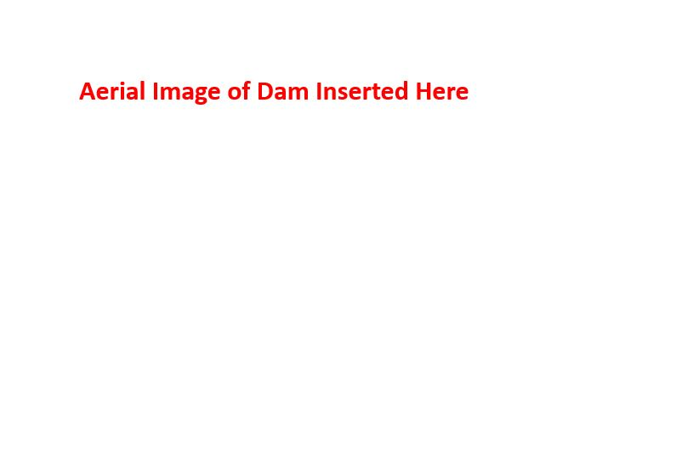

Revision # 0
This document contains sensitive information critical to the protection of life and property and should be distributed to personnel key to the management of incidents at this dam.

Essential Dam Information
Dam Name: DamName |  | Alternate Dam Name: XXXXX or (n/a)
SC ID #: D#### | NID #: SC##### | Hazard Classification:  High/ Significant/ Low/ State Class One | Inspection Frequency:  For High or State Class One: Every 2 years. For Significant: Every 3 years
Lat/Long: ##.#####, -##.##### |  | County: XXXXX | Regional Office: SCDES RegionName-Location
Impounded Stream (if applicable): StreamName  (or if applicable, Tributary to StreamName) |  |  | Tax Map Number(s):  ###-#####-###.##  (Format will vary by county)
Height (ft.): ### | Maximum Impoundment (acre - ft.): ###
Potential Downstream Impacts: These may include, but are not limited to, private residences, businesses, regulated dams, and infrastructure. Refer to the 'Potential Inundated Properties' section for additional details.
This description should be tailored as needed to account for a variety of potential downstream impacts if a dam were to fail. Formats may vary. The SCDES example format for pre-populated templates is provided below.
“There are #### potentially inundated structures/sites that fall within the identified inundation zone, including State Regulated High/Significant/Low/State Class One Hazard Dam NAME
Road(s)
- RoadName (SCDOT road ID if applicable) which has an average traffic count of #### cars/day
- RoadName (SCDOT road ID if applicable) which has an average traffic count of #### cars/day
- Etc.

fall(s) within the inundation boundary and will likely be impacted in the event of dam failure.

In addition, parks/a wastewater treatment facility/school/other facility/etc. falls within the inundation zone.”

Additional Information (for Dam Inspectors or First Responders): Please list any upstream regulated dams, access limitations (gates, locks), known safety hazards on the dam property, or other information that visitors to the site should be aware of.

This field can include a wide range of information and should be used as needed. Common items included on SCDES pre-populated templates are:
- Upstream state regulated dams that may impact this dam if they were to fail
- Owner/operator provided site access information, inc. gate codes or key phone numbers for access
- Owner/operator provided recommended dam operational procedures
- Etc.

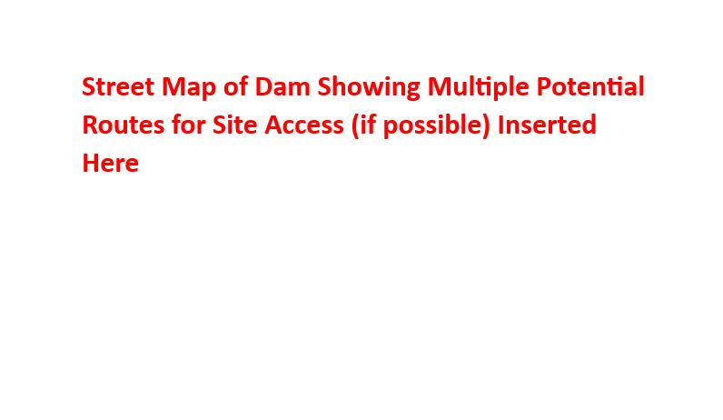
Table of Contents

Essential Dam Information 2
Dam Owner/Operator Signatures 5
Purpose 6
Information for Dam Owners 7
South Carolina Regulated Dam Definitions 7
Dam Owner Information 8
Dam Operator Information 9
Additional Contact Information 9
Roles and Responsibilities 11
Dam Owner/Operator 11
County Emergency Management Agencies 11
The Department of Health and Environmental Control 12
South Carolina Emergency Management Division (SCEMD) 12
Identifying an Emergency 13
Dam Failure Imminent or in Progress 13
Potential Dam Failure 13
Non-Emergency Event 13
Emergency Response 16
Dam Failure Imminent or in Progress 17
Potential Dam Failure 18
Non-Emergency Event 19
Potentially Inundated Properties 20
Inundation Maps 24
Revision History 27

Dam Owner/Operator Signatures

The undersigned affirm that they are owners or operators of the South Carolina regulated dam DXXXX, Name of Dam as defined under the South Carolina Dams and Reservoirs Safety Act Section 49-11-120(9) or have the legal authority to sign on behalf of an owner or operator.
The undersigned state that they have reviewed this Emergency Action Plan in full and the information contained within is valid to the best of their knowledge. The undersigned are aware of their roles and responsibilities to implement the plan under unusual or emergency conditions.

_______________________  Dam Owner(s) | _______________________  Signature | _______________________  Date
_______________________  Additional Dam Owner(s)/Operator(s)-add as needed | _______________________  Signature | _______________________  Date

-------------------------------------------------------------------------------------------------------------------------------For Department Use Only:
Revision # 0
Accepted Date _____________
SCDES Staff Initials ____________

Purpose

An Emergency Action Plan (EAP) is a formal document that assists dam owner(s) in identifying potentially unusual or emergency conditions at a dam and prescribes specific actions that minimize potential loss of life and property damage. Up-to-date EAPs are required for all dams classified as High or Significant Hazard by the South Carolina Department of Environmental Services (SCDES), hereafter referred to as the Department. The Department has provided this template to aid dam owner(s) in completing an EAP that will satisfy Departmental requirements. The SC Dams and Reservoirs Safety Act, S.C. Code Ann. 49-11-110, et seq. (2008) and Regulations 72-1, et seq. (2012) authorize South Carolina's Dams and Reservoirs Safety Program to regulate certain South Carolina dams. The minimum requirements for an emergency action plan shall be the following, under SC Dams and Reservoirs Safety Act Regulation 72-4, et seq. (2012):
- The EAP shall be on a format sheet provided by the Department.
- The EAP shall include a written listing of the specific actions that shall be taken if there is reason to conclude the dam is near failure or has failed. This shall include the responsibility of the dam owner to notify any potentially inundated property owners.
The key components of an EAP are:
- Essential information about the dam structure as well as any potential downstream hazards that would be impacted by a dam failure
- Clearly defined roles and responsibilities of dam owners, regulatory agencies, and local emergency services
- Essential information for dam owners and resources to assist them in assessing the condition of their dam and identifying potential emergency situations
- Contact information and detailed notification processes for emergency services and local resources essential in an emergency response
This template document was established using guidelines and format recommendations contained within the Federal Emergency Management Agency’s Federal Guidelines for Dam Safety-Emergency Action Plans for Dams (FEMA-64). Not all recommendations of FEMA-64 are accounted for in this template. The Department recommends dam owners review these guidelines in full and evaluate. All language and other elements of this template can be edited to tailor the final EAP to the needs of the owner, the characteristics of the dam and downstream area, and to ensure the most effective possible emergency response.
The Department will accept EAPs in an alternative format as long as the key elements of this template document and the key components of an EAP defined above are present to the Department’s satisfaction. Dam owners are directed to contact the Department with questions about alternative formats or for assistance in completing this document.
The purpose of this EAP is to reduce the risk of injury or loss of human life and to minimize property damage during a potential incident or emergency event at regulated dam number D####, commonly known as DamName. It is the responsibility of the dam owner(s) under the law to detect unusual or emergency conditions at their dam and to implement this EAP, as well as to initiate emergency notifications if necessary.

Information for Dam Owners
Frequency
An updated copy of this EAP must be provided at scheduled routine preliminary inspections performed by the Department, or its agents as authorized by the SC Dams and Reservoirs Safety Act Regulation 72-4, et seq. (2012). High Hazard dams will be inspected at a minimum frequency of every two (2) years while Significant Hazard dams will be inspected at a minimum frequency of every three (3) years. Dam owners are generally notified of these inspections at least three weeks in advance. Any owner(s) of a state regulated dam that does not provide an updated copy of an EAP at or prior to the scheduled inspection may be subject to compliance/enforcement actions and administrative fines. It is recommended that the EAP be updated annually or as changes occur to ensure all information is accurate and the EAP can be exercised effectively in unusual or emergency conditions. Revised EAPs can be submitted directly to the Department at any time.
Distribution
Upon verification of the EAP, the owner(s) is/are responsible for distributing the document to any necessary parties. All owners should retain a copy for use during unusual or emergency conditions. EAP holders must destroy outdated EAP copies upon receipt of an updated version. Owners are responsible for keeping track of all EAP holders and providing updated EAPs to all parties as changes are made.

South Carolina Regulated Dam Definitions
The South Carolina Dams and Reservoirs Safety Act, 49-11-120(4), defines a "Dam" as an artificial barrier with appurtenant works, including, but not limited to dams, levees, dikes, or floodwalls for the impoundment or diversion of waters or other fluids where failure may cause danger to life or property.
The South Carolina Dams and Reservoirs Safety Act, 49-11-120(2), defines "Appurtenant works" as including but not limited to, structures such as spillways (either in the dam or separate from it), low-level outlet works, and water conduits.
The South Carolina Dams and Reservoirs Safety Act, 49-11-120(9), defines a dam "Owner" as one who owns, controls, operates, maintains, manages, or proposes to construct a dam or reservoir.
In cases where the Department is attempting to reestablish ownership of a dam, the Department first looks to those entities who hold title to the property on which the dam is constructed or to those entities who have acquired some legal responsibility for the dam through covenants or other similar agreements. If no such entities can be determined, the Department then looks to other entities who may fall under the statutory and regulatory definition of an "owner."
The below parties are considered dam owner(s) under these definitions. Listings are derived from departmental records or best available county land records. Updated contact information should be provided in the indicated fields. Any ownership changes, additions, clarifications, or contestations will be reviewed and verified by the Department. A "Change of Ownership" form is available from the Department and a copy should be submitted to the Department if ownership is transferred between parties. When this occurs, the EAP should be revised to reflect the change.

Dam Owner Information
In the event that a dam owner is unable or unavailable to fulfill the responsibilities as listed in this document, contact information should be provided for a representative who will be prepared to identify and react to unusual or emergency conditions at the dam and initiate emergency notifications.
- Owner Name (company or person): ________________________________________________
Phone: __________________________ Alternate Phone: __________________________
Mailing Address: _______________________________________________________________
City: __________________________ State: _________________ Zip: ________
Email Address: __________________________________________
Owner Representative (if applicable): ______________________________________________________
Phone: ________________________________ Alternate Phone: _________________________
Mailing Address: ________________________________________________________________
City: ___________________________________ State: _______________ Zip: ______________
Email Address: _______________________Is Person/Entity a Local Contact? ____ Yes ____ No

- Owner Name (company or person): ________________________________________________
Phone: __________________________ Alternate Phone: __________________________
Mailing Address: _______________________________________________________________
City: __________________________ State: _________________ Zip: ________
Email Address: __________________________________________
Owner Representative (if applicable): ______________________________________________________
Phone: ________________________________ Alternate Phone: _________________________
Mailing Address: ________________________________________________________________
City: ___________________________________ State: _______________ Zip: ______________
Email Address: _______________________Is Person/Entity a Local Contact? ____ Yes ____ No

Dam Operator Information
The South Carolina Dams and Reservoirs Safety Act Regulations, 72-1(G), states that to "Operate" a dam or reservoir means to perform functions intended to preserve or protect the dam or reservoir (or the area potentially impacted by the dam or reservoir). Examples of operator functions include removal or replacement of flashboards, opening or closing of gates, removal of accumulated trash at the spillway, and maintenance functions such as mowing grass on the dam, etc. Space to enter the dam operator contact information has been provided, but filling in these fields is not required. A Dam Owner may also act in the role as the Operator for their dam.
- Operator Name (company or person): _______________________________________________
Phone: ________________________________ Alternate Phone: _________________________
Mailing Address: ________________________________________________________________
City: ____________________________ State: ____________________ Zip: _______________
Email Address: _________________________________________________________________

- Operator Name (company or person): _______________________________________________
Phone: ________________________________ Alternate Phone: _________________________
Mailing Address: ________________________________________________________________
City: ____________________________ State: ____________________ Zip: _______________
Email Address: _________________________________________________________________

Additional Contact Information
The below parties are not Dam Owners or Dam Operators as defined above but have been identified as having some other role in regards to it.
Name: ___________________________________________________________________________
Relation to Dam: ___________________________________________________________________
Phone: _________________________________ Alternate Phone: ____________________________
Mailing Address: ___________________________________________________________________
City: _______________________________________ State: _______________ Zip: _____________
Email Address: ________________________ Is Person/Entity a Local Contact? _____ Yes _____No

Name: ___________________________________________________________________________
Relation to Dam: ___________________________________________________________________
Phone: _________________________________ Alternate Phone: ____________________________
Mailing Address: ___________________________________________________________________
City: _______________________________________ State: _______________ Zip: _____________
Email Address: ________________________ Is Person/Entity a Local Contact? _____ Yes _____No

Name: ___________________________________________________________________________
Relation to Dam: ___________________________________________________________________
Phone: _________________________________ Alternate Phone: ____________________________
Mailing Address: ___________________________________________________________________
City: _______________________________________ State: _______________ Zip: _____________
Email Address: ________________________ Is Person/Entity a Local Contact? _____ Yes _____No

Roles and Responsibilities

Dam Owner/Operator
The Dam Owner(s) is/are responsible for safe maintenance and operation of the dam and reservoir. The Dam Owner(s) is/are also the primary party responsible for implementing this EAP. The owner(s) must conduct frequent visual inspections using guidance provided in this document to detect any changes that may endanger the dam. Upon detection of potential dam deficiencies, the Dam Owner(s) must assess the severity of the situation and implement the EAP accordingly, including initiating emergency notifications. Under unusual or emergency conditions, the owner(s) must take appropriate actions to save the dam and make appropriate notifications.

As soon as an event is observed or reported, the Dam Owner(s) must immediately determine the severity of the situation based on the Identifying an Emergency section of this document. Once the severity level of the situation has been determined, the Dam Owner(s) is/are responsible for making the appropriate notifications based on the phone trees located in the Emergency Response section of this document.

County Emergency Management Agencies
County Emergency Management Agencies will generally be responsible for the following tasks (if applicable) to support Dam Owners. Resources may vary by county and dam owners are encouraged to familiarize themselves with local emergency management services and procedures. The presence of an item listed below is no guarantee that those services will actually be available in the event of a dam emergency. Dam Owners should coordinate with County Emergency Management Agencies to determine specific services and processes that are or are not available for that county.
- Maintaining available EAPs for dams located in the county or whose failure would affect the county
- Coordinating evacuation traffic management and if necessary developing evacuation zones
- Dispatching local law enforcement, 911, and first responders as needed
- Contacting National Weather Service during an emergency event
- Developing a mass care plan to identify shelter locations to support anticipated displaced populations
- Working with utilities and service providers to determine a means to repair or restore essential services.
- Participating in dam failure training and exercises
- Disseminating public information and, if available, providing an authorized spokesperson to support public information activities at the Joint Information Center (JIC)
- Coordinating swift water rescue operations
- Providing the State Emergency Operations Center (SEOC) with reports to include status of dam, evacuation, support services, deaths, injuries, and damages
- Coordinating with SEOC for resources not available or needs beyond the County's capabilities
- Implementing reverse 911 calls to inundated properties in counties where the service is available

The Department of Environmental Services (SCDES)
The Department of Environmental Services is responsible for the following tasks (if applicable) to support dam owners.
- Assisting dam owners in developing Emergency Action Plans
- Assisting affected counties in developing Emergency Action Plans and/or Site-Specific Plans
- Activating the ReadyOp system in advance of forecasted tropical or major storm events to notify dam owners of an increased potential of a dam incident and providing proactive measures for owners to take
- Providing technical support in managing a dam incident in progress
- Following up with the dam owner(s) after an emergency event to determine appropriate follow-up actions

South Carolina Emergency Management Division (SCEMD)
The South Carolina Emergency Management Division is responsible for the following tasks (if applicable) to support dam owners.
- Monitoring potentially threatening conditions affecting South Carolina that may cause deteriorating conditions to dams, and coordinating appropriate warning and response actions
- Assisting affected counties in developing Emergency Action Plans and/or Site-Specific Plans
- In coordination with affected counties, SC Department of Public Safety (SCDPS), and SC Department of Transportation (SCDOT), developing evacuation zones based on the inundation maps
- Assisting dam owners and other agencies with dam safety training, public information, and education
- Participating in exercises to test state and local plans
- Supporting county emergency operations during dam emergencies
- Advising the Governor, state agencies, local government officials, and, if necessary, Federal agencies of the severity and magnitude of the dam failure emergency/disaster situation
- Coordinating with the county, dam owner, and National Weather Service, and other agencies to release consistent information
- Maintaining and reviewing copies of available dam EAPs and ensuring consistency with state and local protocol

Identifying an Emergency

It is the responsibility of the Dam Owner(s) to monitor the dam for possible deficiencies. Please contact the Department for additional assistance and resources with identifying potential emergency situations. The below condition tiers are standardized examples and Dam Owners are welcome to recategorize or add additional tiers or conditions as needed. Additional “High Flow” alerts as described in FEMA-64 are not included below, but Dam Owners are encouraged to consider if one would be appropriate for their structure.

Dam Failure Imminent or in Progress
This indicates an urgent condition in which the dam is failing, is about to fail, or has failed. "Imminent Failure" typically involves a continuing and progressive loss of material from the dam. For the purposes of evacuation, emergency management authorities may assume the worst-case condition that a failure has already occurred.

Potential Dam Failure
This indicates that conditions are developing at the dam that could lead to a dam failure. "Potential Failure" should convey that time is available for analyses, decisions, and actions before the dam could fail. A failure may occur, but predetermined response actions may moderate or alleviate failure.

Non-failure
This indicates an event at a dam that will not, by itself, lead to a dam failure, but requires investigation and notification of appropriate personnel.

Classification of Dam Deficiencies
Sample Guidance from FEMA P-64 Federal Guidelines for Emergency Action Planning for Dams (2013)
If any of these deficiencies are observed at the dam, immediately implement the appropriate notification pathway described and begin monitoring the dam. If at any time the dam appears to be failing, consider it an ‘Imminent Failure’ and take all proper emergency action steps. This list is not exhaustive and dam owners should account for other site-specific issues if applicable and insert site- and dam-specific values below wherever possible
Event | Situation | Emergency Level
Earth Spillway Flow | Reservoir water surface elevation at auxiliary spillway crest or  spillway is flowing with no active erosion | Non-failure
 | Spillway flowing with active gully erosion | Potential Failure
 | Spillway flow that could result in flood of people downstream if the  reservoir level continues to rise | Potential Failure
 | Spillway flowing with an advancing headcut that is threatening the control section | Imminent Failure
Embankment Overtopping | Reservoir level is XX feet/inches below the top of the dam | Potential failure
 | Water from the reservoir is flowing over the top of the dam | Imminent failure
Seepage | New seepage areas in or near dam | Non-failure
 | New seepage areas with cloudy discharge or increasing flow rate | Potential Failure
 | Seepage with discharge greater than XX gallons per minute | Imminent failure
Sinkholes | Observation of new sinkhole in reservoir area or on embankment | Potential Failure
 | Rapidly enlarging sinkhole | Imminent failure
Embankment Cracking | New cracks in the embankment greater than XX inches wide without seepage | Non-failure
 | Cracks in the embankment with seepage | Potential Failure
Embankment Movements | Visual movement/slippage of the embankment slope | Non-failure
 | Sudden or rapidly proceeding slides of the embankment slopes | Imminent failure
Instruments | Instrumentation readings beyond predetermined values | Non-failure
Earthquake | Measurable earthquake felt or reported on or within XX miles of the dam | Non-failure
 | Earthquake resulted in visible damage to the dam or appurtenances | Potential Failure
 | Earthquake resulted in uncontrolled release of water from the dam | Imminent failure
Security Threat | Verified bomb threat that, if carried out, could result in damage to the dam | Potential failure
 | Detonated bomb that has resulted in damage to the dam or appurtenances | Imminent failure
Sabotage/Vandalism | Damage that could adversely impact the functioning of the dam | Non-failure
 | Damage that has resulted in seepage flow | Potential failure
 | Damage that has resulted in uncontrolled water release | Imminent failure

Emergency Response
The following flowcharts show who the Dam Owner(s) will notify once a dam deficiency has been determined to exist and the severity of that deficiency (as detailed in the previous section) has been assessed. If the dam's potentially inundated area (as determined through the inundation map contained within this document) crosses county boundaries, notifications should be executed for all applicable counties where downstream hazards are present in the chosen scenario.
The flowchart boxes below represent the general flow of notifications during each scenario condition. A box may in fact represent a set of additional notifications or sub-notifications to the listed party. Dam Owners should be as detailed as possible in documenting the parties to be involved in an emergency response when developing or revising an EAP.
Under state laws and regulations, it is the responsibility of the dam owner to initiate emergency notifications in the event of a dam emergency and to ensure that those at-risk downstream are properly notified. Dam owners are encouraged to coordinate with emergency management agencies and SCDES on developing the best procedures and tools for effective alerts in the event of a dam failure.

Dam Failure Imminent or in Progress
An urgent condition in which the dam is failing, is about to fail, or has failed. "Imminent Failure" typically involves a continuing and progressive loss of material from the dam. For the purposes of evacuation, emergency management authorities may assume the worst-case condition that failure has already occurred.
This situation is extremely urgent. The dam owner(s) must call 911 as well as the local Emergency Management Services and the Department. Next, the owner(s) is/are to notify the list of potentially inundated structures or sites listed in the Potentially Inundated Properties section of this EAP.
Imminent Failure
Calling order flows from left to right

In the event of imminent failure, the following language may be used to describe the situation. The actual notification may vary from this script, but the situation should be accurately described.
This is an emergency. This is (Identify yourself; name, position.) We have an emergency condition at dam D (SC Inventory Number, located at address of dam), and the dam is failing. (Describe the conditions based on the Classification of Dam Deficiencies chart contained herein). We have activated the Emergency Notification and Action Plan and are currently experiencing an imminent failure situation. Please be advised that immediate evacuation of the low-lying area below the dam is necessary. I may be reached at (primary phone number) or (alternate phone number). *Note - provide additional contact information as needed
When contacting 911, ask to speak to the supervisor on duty, as normal operator may not have necessary experience for dam response events.

Potential Dam Failure
Indicates that conditions are developing at the dam that could lead to a dam failure. "Potential Failure" should convey that time is available for analyses, decisions, and actions before the dam could fail. A failure may occur, but predetermined response actions may moderate or alleviate failure.
Potential Failure
Calling order flows from left to right

In the event of potential failure, the following language may be used to describe the situation. The actual notification may vary from this script, but the situation should be accurately described.
This is (Identify yourself; name, position). We have an emergency condition at dam D (SC Inventory Number, located at address of dam). (Describe the conditions based on the Classification of Dam Deficiencies chart contained herein). We have activated the Emergency Notification and Action Plan and are currently having a potential failure event. We are implementing predetermined actions to respond to a situation that could result in dam failure in order to save the dam. Please be advised that evacuation of the low-lying area below the dam may become necessary. We will advise you when the situation is resolved, or if the situation gets worse. I may be reached at (primary phone number) or (alternate phone number). *Note - provide additional contact information as needed
When contacting 911, ask to speak to the supervisor on duty, as normal operator may not have necessary experience for dam response events.

Non-Emergency Event
Appropriate for an event at a dam that will not, by itself, lead to a dam failure, but requires investigation and notification of appropriate personnel.
The situation has not yet threatened the integrity of the dam. The Department should be notified immediately, and the dam should be monitored by the owner(s).
If an event occurs outside of regular office hours, the owner(s) may call the Department emergency phone number.
Non-Emergency Event
Calling order flows from left to right

Potentially Inundated Properties
The Department’s current catalog of Inundation Maps is available online at: http://gis.dhec.sc.gov/scdams. These maps were developed using DSS-WISE Lite Inundation Methodology. Alternate modeling methodology may be accepted with Department approval. If a SCDES DSS-WISE model is incorporated into this EAP, a notification plan that accounts for all at-risk sites and other secondary impacts identified through that model must also be present. If alternate methodology is used, all at-risk sites and secondary impacts identified in the model must be accounted for in this notification plan, as well as any others that are unlisted but found in the Department’s model.
The following structures/sites have been determined to be at risk of being inundated after a dam failure. This list is to be used to assist in emergency response or evacuation planning and implementation and should be updated to reflect new development or demolished structures within the inundation zone or refinement of the inundation zone through new mapping. At minimum, dam owners are required to notify the below parties if a dam failure is underway or has occurred. Contact information should be updated as necessary. The listed addresses are impacted site locations and not mailing addresses for site owners. GPS coordinates have been substituted where site addresses are not available.

- Name: ________________________________
Phone: ______________________________
Site Location: _______________________
City: __________ State: ____ Zip: _________
Tax Map Number: _____________

- Name: ________________________________
Phone: ______________________________
Site Location: _______________________
City: __________ State: ____ Zip: _________
Tax Map Number: _____________

- Name: ________________________________
Phone: ______________________________
Site Location: _______________________
City: __________ State: ____ Zip: _________
Tax Map Number: _____________

- Name: ________________________________
Phone: ______________________________
Site Location: _______________________
City: __________ State: ____ Zip: _________
Tax Map Number: _____________

- Name: ________________________________
Phone: ______________________________
Site Location: _______________________
City: __________ State: ____ Zip: _________
Tax Map Number: _____________

- Name: ________________________________
Phone: ______________________________
Site Location: _______________________
City: __________ State: ____ Zip: _________
Tax Map Number: _____________

- Name: ________________________________
Phone: ______________________________
Site Location: _______________________
City: __________ State: ____ Zip: _________
Tax Map Number: _____________

- Name: ________________________________
Phone: ______________________________
Site Location: _______________________
City: __________ State: ____ Zip: _________
Tax Map Number: _____________

- Name: ________________________________
Phone: ______________________________
Site Location: _______________________
City: __________ State: ____ Zip: _________
Tax Map Number: _____________

- Name: ________________________________
Phone: ______________________________
Site Location: _______________________
City: __________ State: ____ Zip: _________
Tax Map Number: _____________

Additional spaces have been provided below for the Dam Owner to fill in as necessary.
Additional Inundated Sites
Name: ____________________________________ Phone: ___________________________________
Site Location: ________________________________________________________________________
Tax Map Number: ____________________________________________________________________

Name: ____________________________________ Phone: ___________________________________
Site Location: ________________________________________________________________________
Tax Map Number: ____________________________________________________________________

Name: ____________________________________ Phone: ___________________________________
Site Location: ________________________________________________________________________
Tax Map Number: ____________________________________________________________________

Name: ____________________________________ Phone: ___________________________________
Site Location: ________________________________________________________________________
Tax Map Number: ____________________________________________________________________

Name: ____________________________________ Phone: ___________________________________
Site Location: ________________________________________________________________________
Tax Map Number: ____________________________________________________________________

Name: ____________________________________ Phone: ___________________________________
Site Location: ________________________________________________________________________
Tax Map Number: ____________________________________________________________________

Name: ____________________________________ Phone: ___________________________________
Site Location: ________________________________________________________________________
Tax Map Number: ____________________________________________________________________

Name: ____________________________________ Phone: ___________________________________
Site Location: ________________________________________________________________________
Tax Map Number: ____________________________________________________________________

Name: ____________________________________ Phone: ___________________________________
Site Location: ________________________________________________________________________
Tax Map Number: ____________________________________________________________________

Name: ____________________________________ Phone: ___________________________________
Site Location: ________________________________________________________________________
Tax Map Number: ___________________________________________________________________

Inundation Maps

Inundation maps assist a Dam Owner(s) and emergency management authorities in identifying critical at-risk sites that may require protective measures and warning and evacuation planning. If the following inundation boundary has been provided by the Department, it was created using the DSS-WISE Lite modeling method. Alternate inundation maps may be included if they have been approved by the Department. Dam owners are encouraged to be cautious when developing inundation maps and emergency notification plans. All inundation maps provided by the Department are to be used for general reference only. The Department makes no warranty, representation or guarantee as to the content, sequence, accuracy, timeliness or completeness of any of the information provided in such maps. The Department, its contractors, suppliers, and consultants assume no liability for any damages due to errors, omissions, or positional accuracy in products. For a more in-depth view of a DSS-WISE Lite inundation zone, please use the SC Dam Safety Inundation web tool located at:
http://gis.dhec.sc.gov/scdams

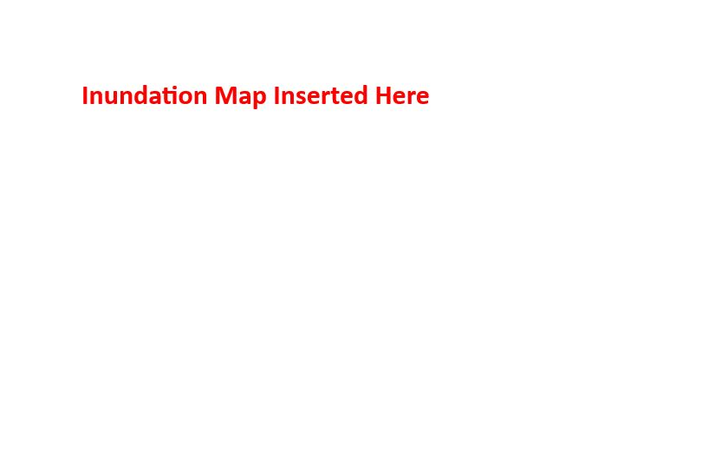
DAM NUMBER: D####
DAM NAME: DamName

Revision Number | Date | Description of Changes Made
Example | 7/5/1990 | - -Added New Operator (p.9)  - -Updated Regional SCDES Phone Number (p. 18)  - -Revised Inundation Map to Updated Model (p.24)  - -Updated Potential Downstream Impacts Description (p. 2) and Potentially Inundated Property Contact List (p. 19) to Reflect Updated Model

Revision History

DAM NUMBER: ___________
DAM NAME: ___________________________________

Revision | Date | Changes Made

DAM NUMBER: ___________
DAM NAME: ___________________________________

Revision | Date | Changes Made

DAM NUMBER: ___________
DAM NAME: ___________________________________

Revision | Date | Changes Made

